CS 255 System Design Document Template

This template lays out all the different sections that you need to complete for Project Two. Each section has guidance to prompt your thinking. You will need to continually reference the interview transcript as you work to make sure that you are addressing your client’s needs. There is no required length for the final document. Instead the goal is to complete each section based on what your client’s needs are. Remove this note when you are finished, and replace all bracketed text with the relevant information.

UML Diagrams

UML Use Case Diagram

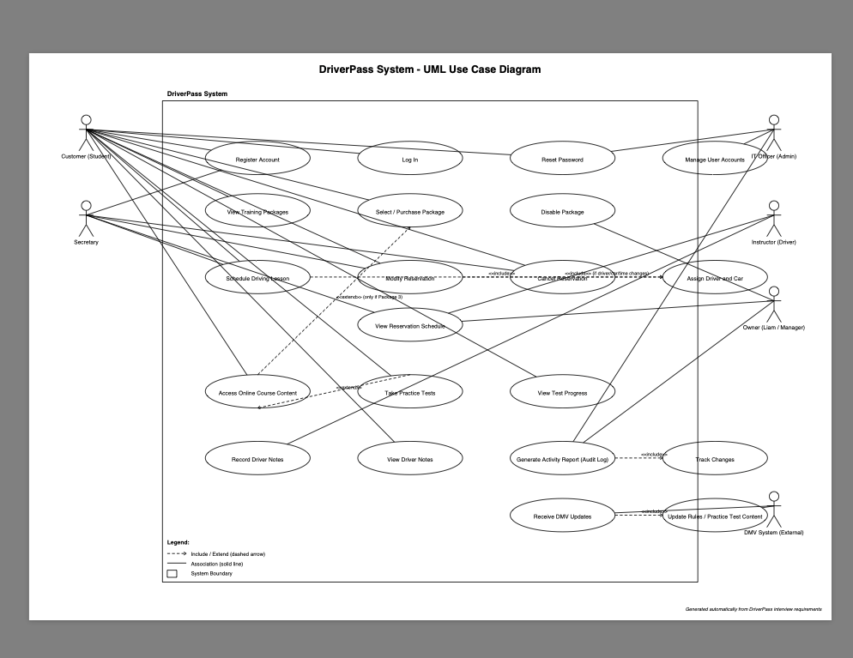

UML Activity Diagrams
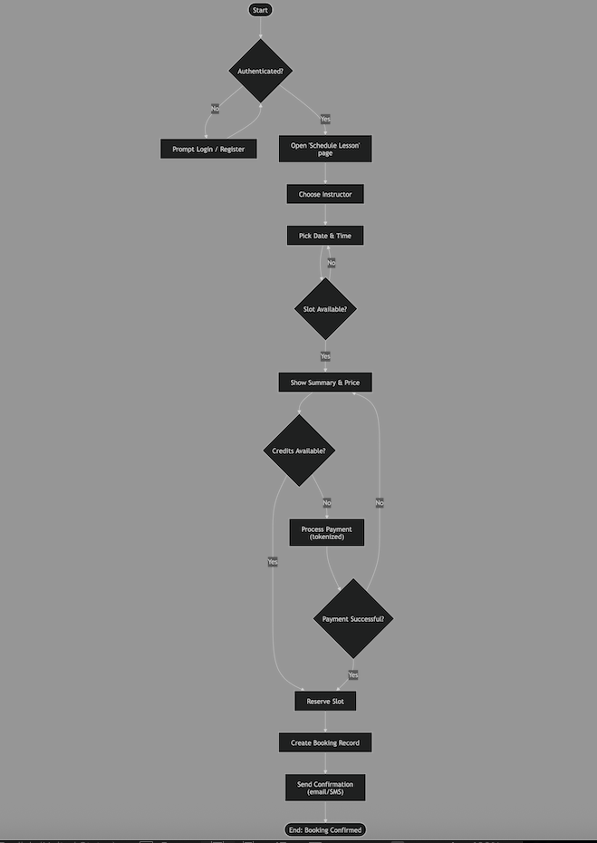

UML Sequence Diagram
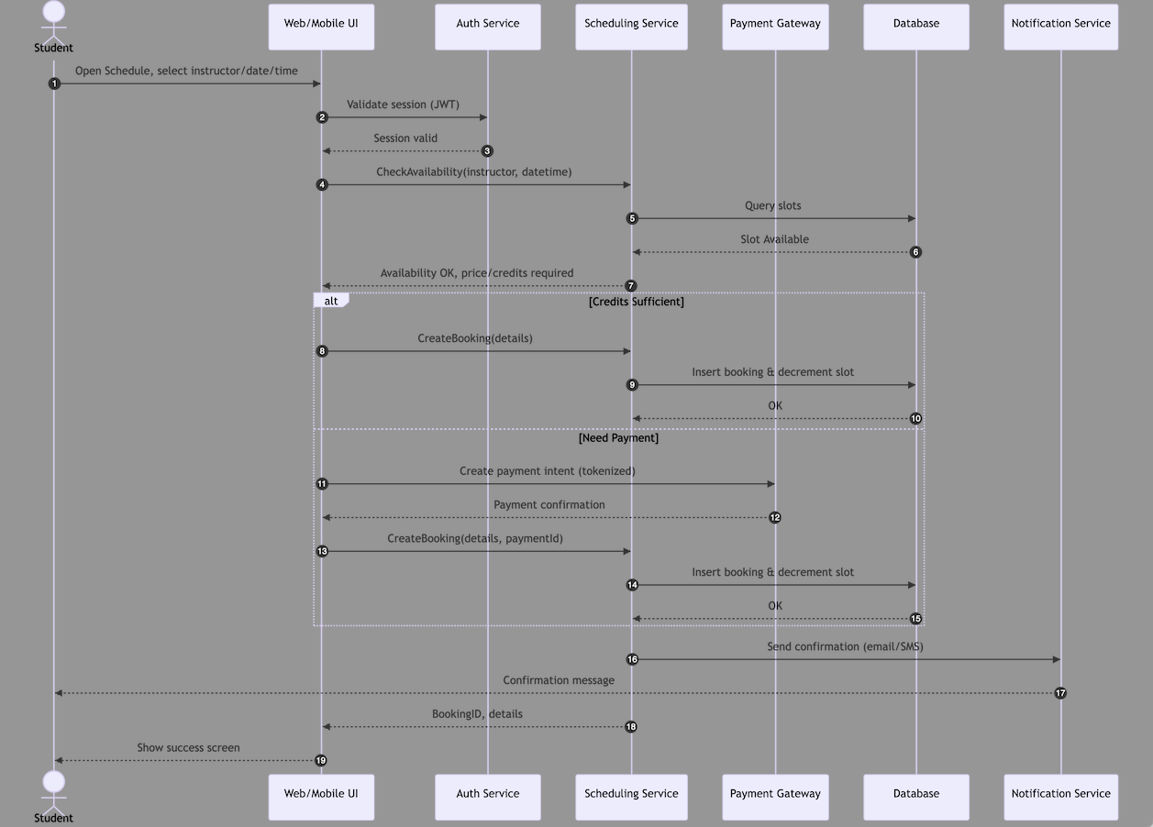

UML Class Diagram

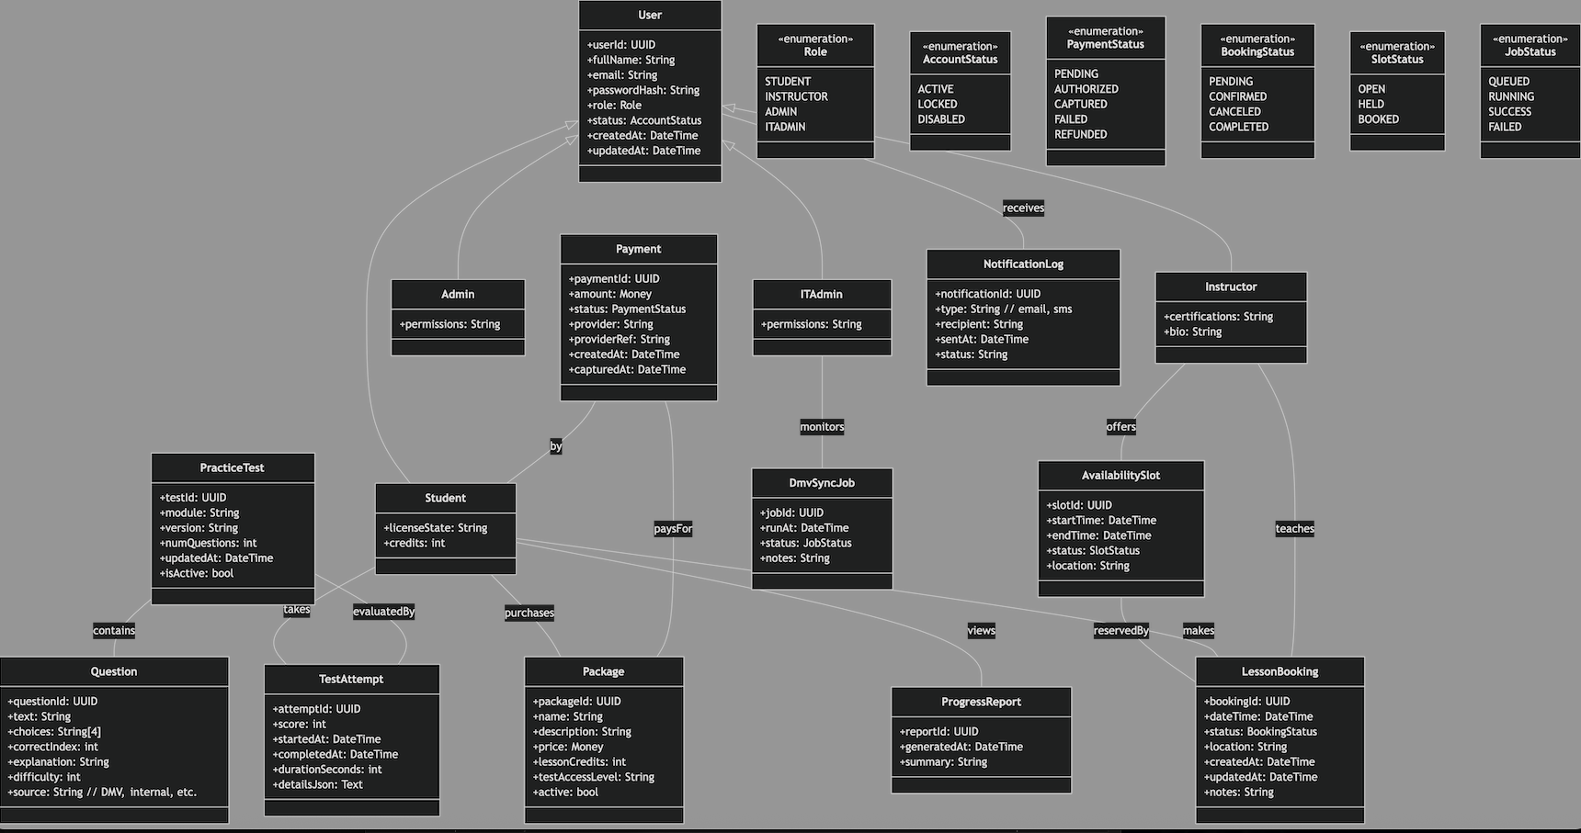

Technical Requirements
The technical requirements for the DriverPass system are defined based on the system’s design, UML diagrams, and functional/nonfunctional requirements outlined in the BRD. These requirements include the hardware, software, development tools, and infrastructure needed to implement, deploy, and maintain the DriverPass platform.

1. System Architecture Requirements
- The system shall follow a three-tier architecture, consisting of:
  - Presentation Layer: Web-based UI accessible through modern browsers.
  - Application Layer: REST-based backend services for authentication, scheduling, testing, payments, and administration.
  - Data Layer: Secure relational database for storing user, package, test, and booking information.
- The architecture shall support horizontal scaling to handle increased user traffic—particularly during peak test-taking periods.
- The system shall support modular separation of services (Auth, Scheduling, Testing, Payments, Admin) to ensure maintainability and future scalability.

2. Hardware Requirements
Server Hardware (Cloud-Hosted or Virtualized):
- Minimum of 4 vCPUs and 8 GB RAM for the backend application server.
- Minimum of 2 vCPUs and 4 GB RAM for supporting containerized microservices.
- Storage:
  - SSD-based storage for low-latency database reads/writes.
  - Minimum of 100 GB expandable storage per environment.
- Networking:
  - Support for load balancers, firewalls, and private network isolation.
Client Hardware:
- Any device capable of running a modern browser (desktop, laptop, tablet, or mobile phone).
- No dedicated hardware is required for end users.

3. Software Requirements

3.1 Front-End Software
- Web technologies:
  - HTML5, CSS3, JavaScript (ES6+)
  - A modern framework such as React, Angular, or Vue
- Responsive design to support desktop and mobile access.
- Browser compatibility:
  - Latest versions of Chrome, Firefox, Safari, and Edge.

3.2 Back-End Software
- Server application implemented using one of the following:
  - Node.js (Express/NestJS)
  - Java Spring Boot
  - .NET Web API
- REST API with JSON serialization.
- JSON Web Tokens (JWT) for authentication state management.

3.3 Database Software
- Relational database system such as:
  - PostgreSQL (preferred)
  - OR MySQL/Azure SQL depending on hosting environment
- Database must support:
  - ACID transactions
  - Multi-table relational design
  - Secure encryption at rest
  - Automated backups

3.4 Additional Supporting Software
- Redis or similar in-memory cache for:
  - Session storage
  - Rate limiting
  - Caching instructor availability
- Docker for containerization and portable deployment.
- CI/CD tools:
  - GitHub Actions
  - Azure DevOps
  - GitLab CI

4. Tools and Development Environment
- Lucidchart for UML modeling (Use Case, Activity, Sequence, Class Diagrams).
- VS Code, IntelliJ, or Visual Studio as primary IDE depending on backend language.
- Git for version control.
- Postman or Insomnia for API testing.
- Jira, Trello, or Azure Boards for project/task management.
- SAST/DAST tools for security scanning.

5. Network & Infrastructure Requirements
- Cloud infrastructure (AWS, Azure, or GCP) with:
  - Load balancer for distributing incoming traffic.
  - Auto-scaling groups for handling high load.
  - Virtual Private Cloud (VPC) with public/private subnet separation.
  - API Gateway for secure backend exposure.
  - SSL certificates (HTTPS) for all public endpoints.
- Firewall rules to restrict database access to application servers only.
- Monitoring & Logging Services:
  - AWS CloudWatch, Azure Monitor, or GCP Logging.
  - Error tracking tools like Sentry or Application Insights.

6. Security Requirements
Based on the UML design and BRD:
- Role-Based Access Control (RBAC):
  - Student
  - Instructor
  - Admin
  - IT Admin
- Authentication Requirements:
  - Secure login using username/password.
  - Password hashing (bcrypt or Argon2).
  - Account lockout after repeated failed attempts.
  - Password reset via secure link.
- Data Transmission Security:
  - All communication must use HTTPS/TLS 1.2+.
- Data Storage Security:
  - Encrypt all data at rest (AES-256).
  - Do not store raw credit card information.
- API Security:
  - JWT-based authentication.
  - Input validation to prevent SQL injection, XSS, CSRF, etc.

7. Payment Integration Requirements
- Integration with a certified PCI-compliant provider (Stripe, PayPal, or Braintree).
- Payment interactions must:
  - Use tokenization (system NEVER stores card data).
  - Support payment confirmation/capture flows.
  - Log only provider reference IDs.

8. System Integration Requirements
- DMV API Integration:
  - Automated synchronization of updated test questions.
  - API calls must be logged and error-handled.
  - Support for versioned practice test content.
- Notification System:
  - Email and SMS integration (e.g., SendGrid, Twilio).
  - Confirmation notifications for bookings, cancellations, reminders, etc.

9. Performance Requirements
- Page load time: 2–3 seconds maximum under normal conditions.
- API latency target:
  - < 500 ms for major operations (login, load tests, scheduling).
- Support for concurrent users:
  - 500+ simultaneous test-takers
  - 1,000+ active users during peak hours
- Database queries must be optimized with indexes for:
  - Lesson booking lookup
  - Instructor availability
  - Test attempts

10. Reliability, Backup, and Recovery Requirements
- Automated daily database backups with point-in-time recovery.
- Deployment pipeline must support:
  - Rolling, blue/green, or canary deployments.
- System availability target: 99.5% uptime minimum.
- Disaster Recovery:
  - RTO ≤ 4 hours
  - RPO ≤ 15 minutes

11. Adaptability & Maintainability Requirements
- System must support:
  - Adding/modifying user roles without code changes.
  - Updating DMV test content without downtime.
  - Adding new modules or packages with minimal architectural changes.
- Codebase must follow:
  - Modular design
  - Consistent naming conventions
  - Clean separation of concerns (per UML diagrams)

